Assignment – 1

Q1. You are working in a company as a Salesforce administrator. You are assigned the following tasks:
a. Set the starting fiscal year of your organization to “March” and ending fiscal year to “February”.
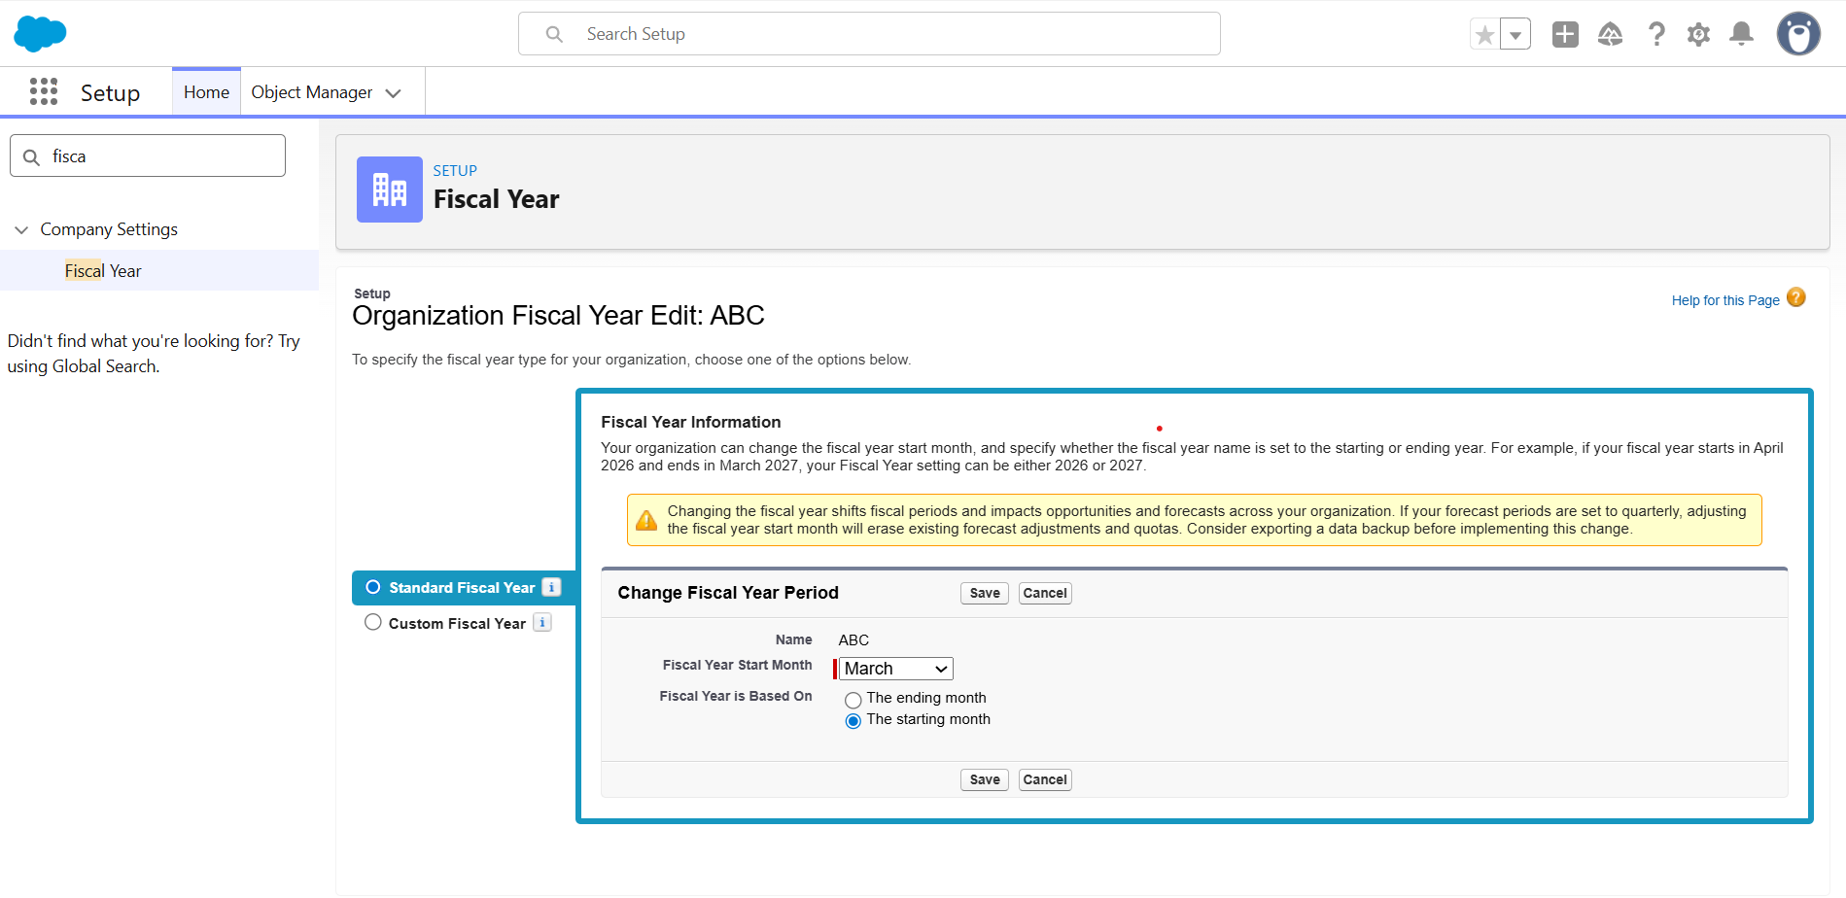
b. Add five fixed holidays for the organization.
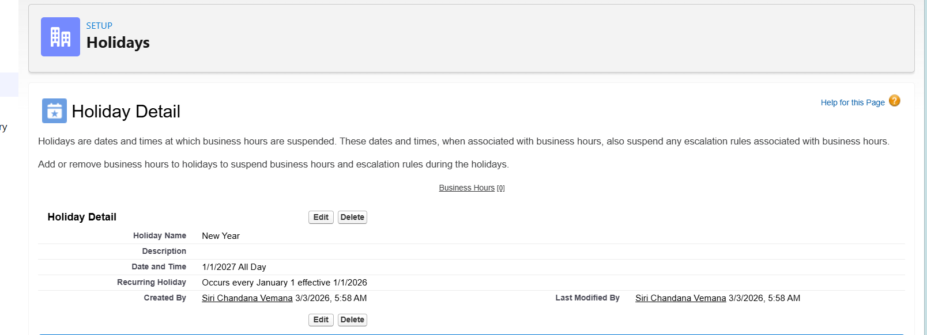

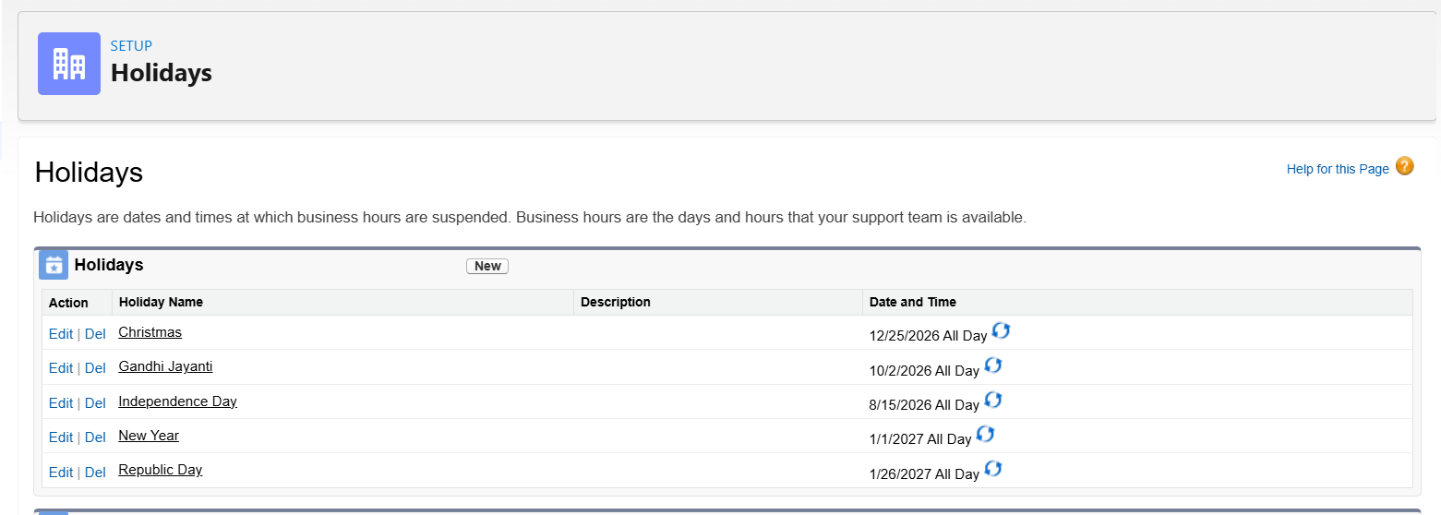

c. Set the default time zone to the Indian Standard Time.
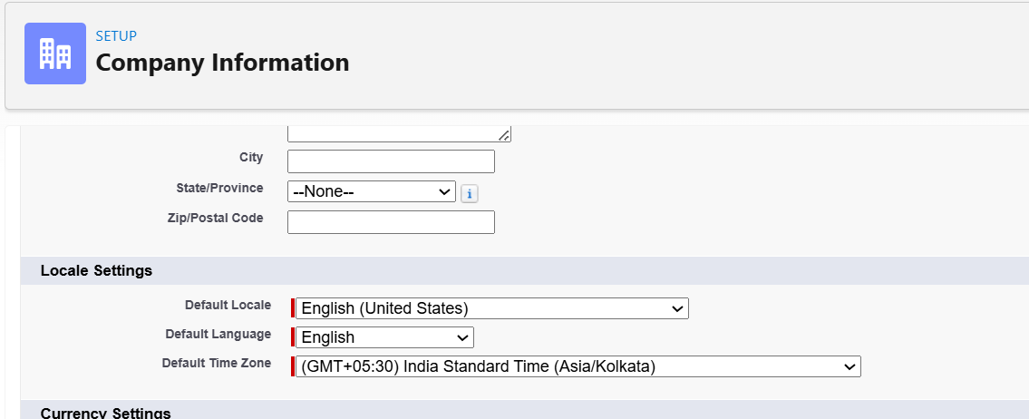

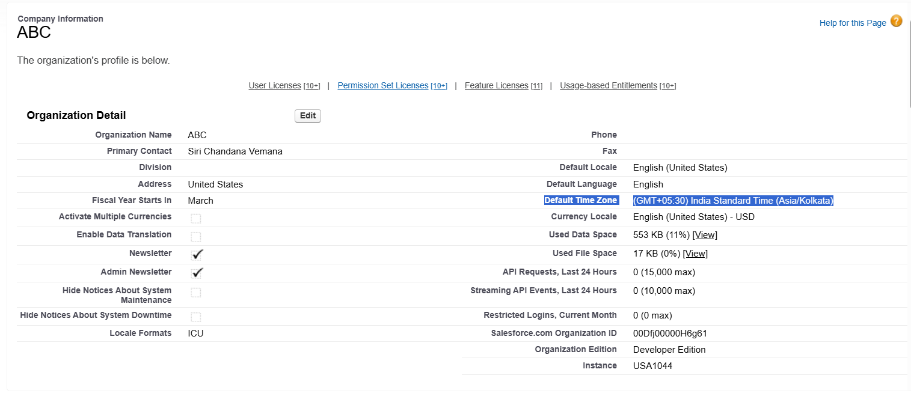

d. Set the language as “English(United States)”.
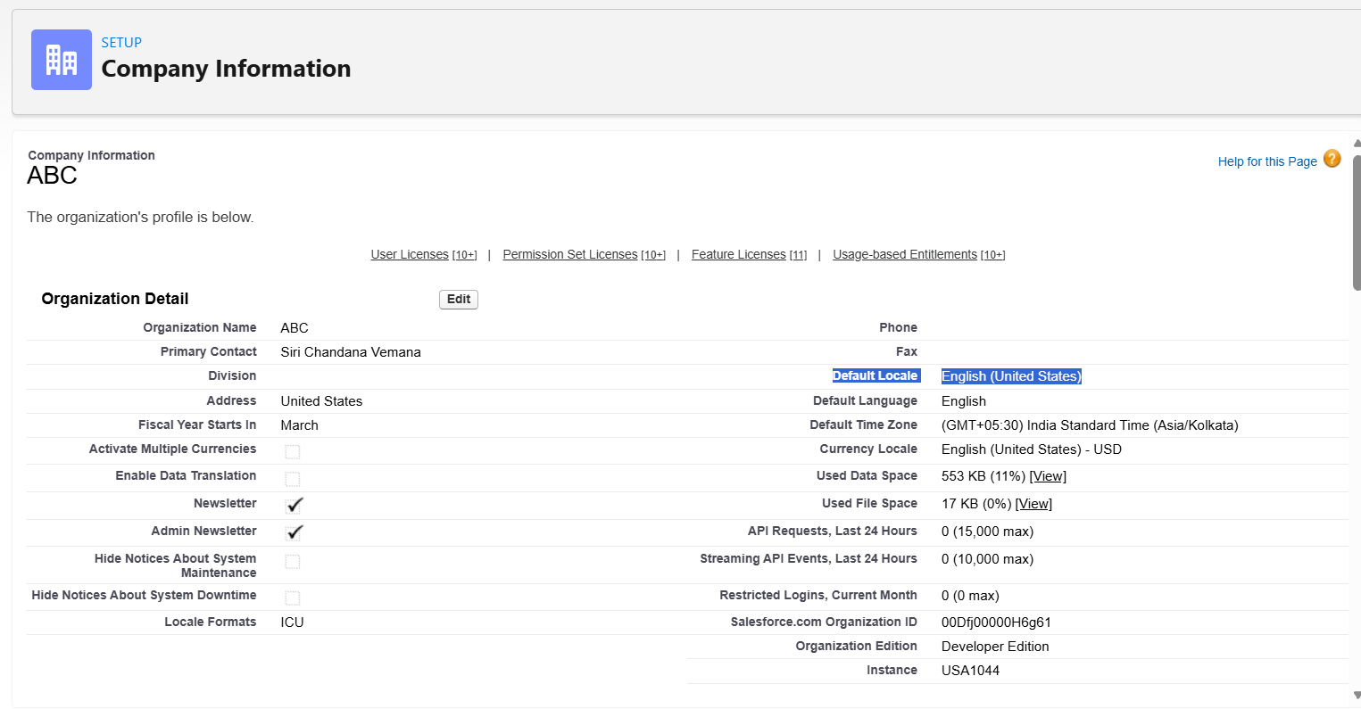

e. Set the business hours of the organization as:
● Monday to Friday from 9 AM to 4 PM.
● Saturday and Sunday from 9 AM to 11 AM.
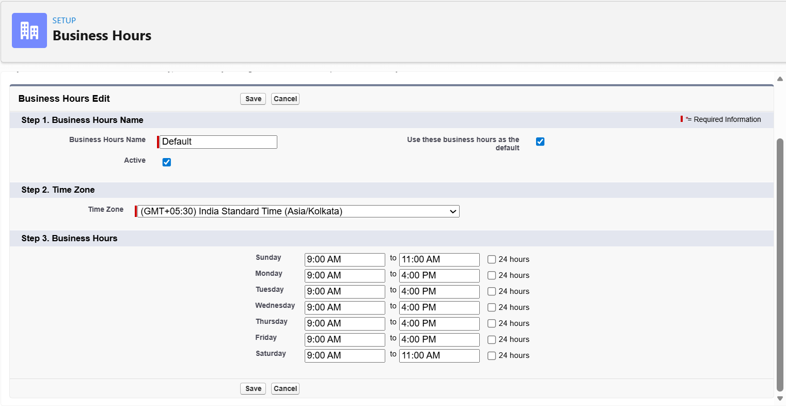

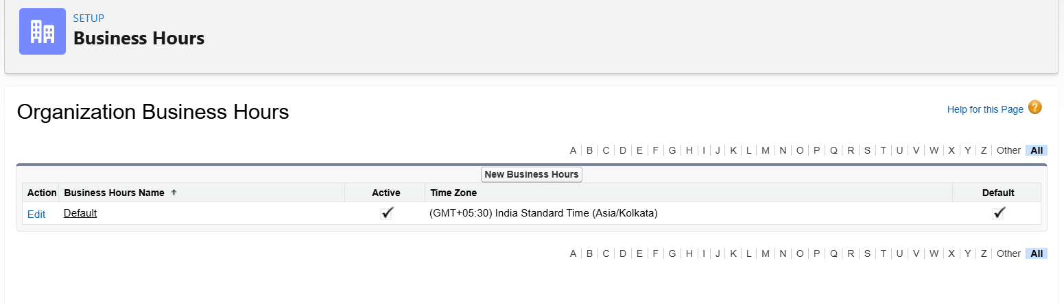
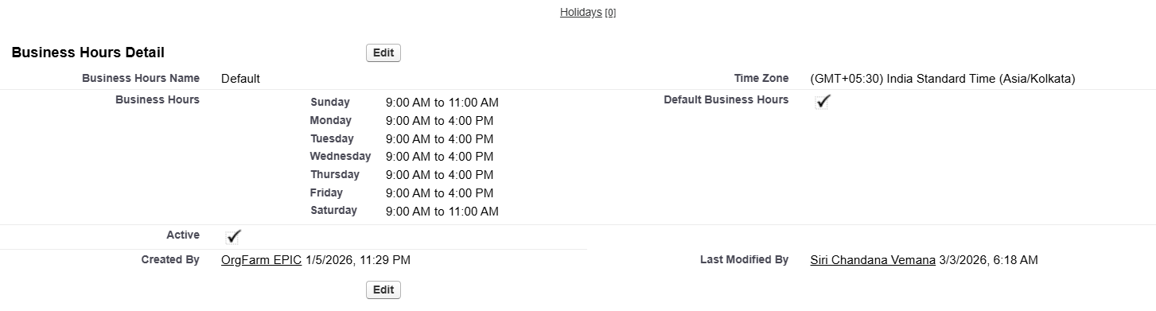

Q2. (i) Your corporate currency is USD. But you head the company’s fast growing Indian Division. Therefore, change your default currency to INR.
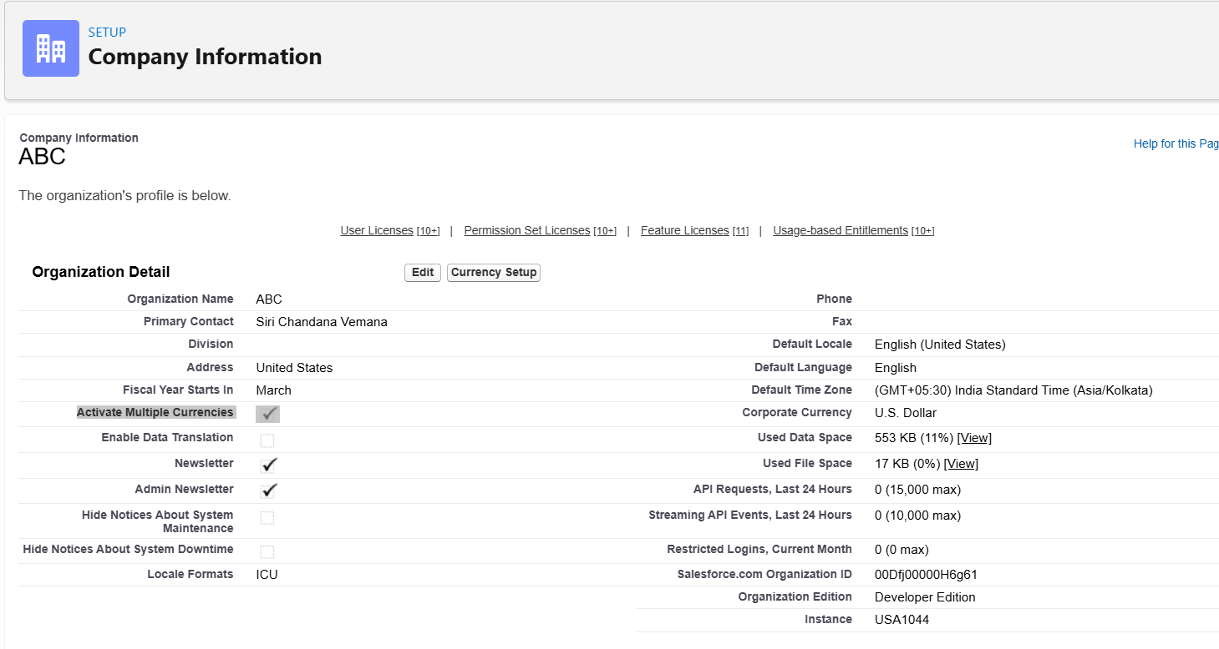

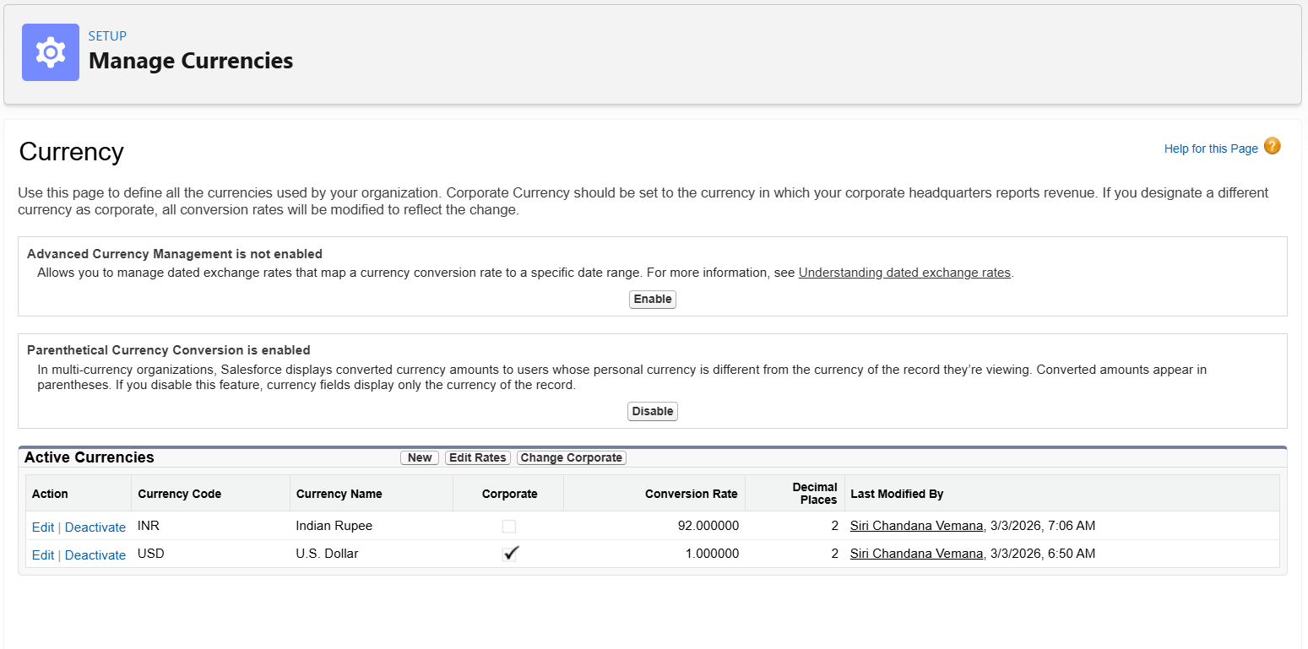

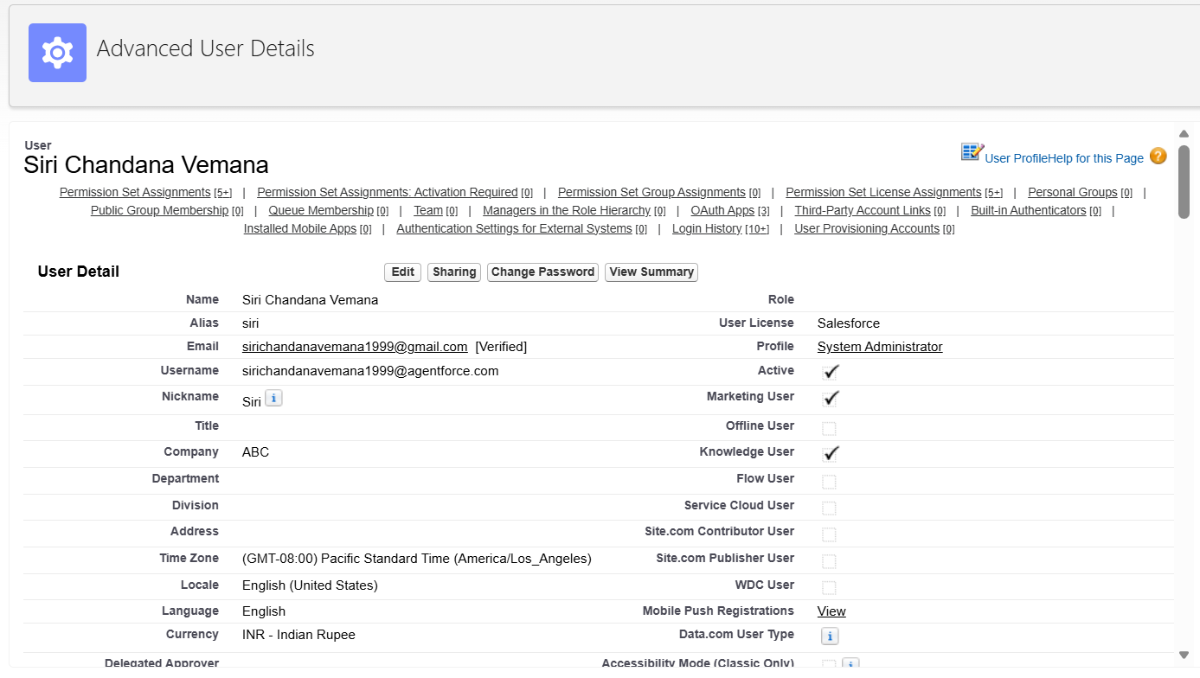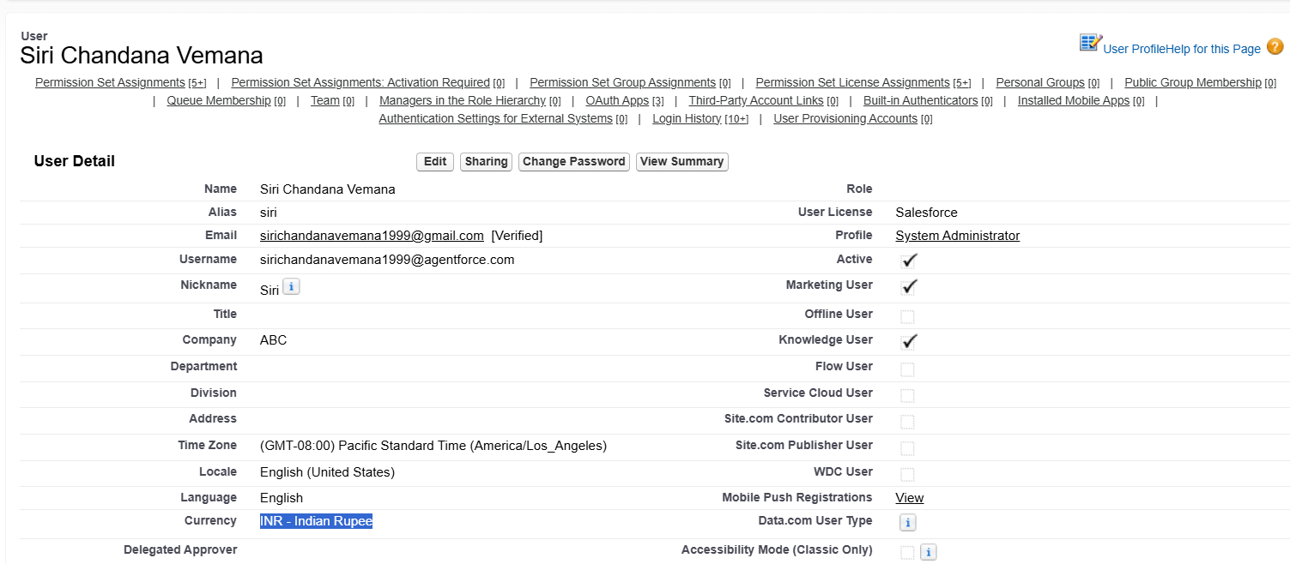

(ii) You are the CEO of the company and your opportunities in USD are getting converted but the USD has been unstable over the past year. How can we handle this situation of fluctuating exchange rate?
